# 

# **An animated wiki for the water cycle**

Author: Shihan Li Advisor: Dr. André Paul Period: August – November, 2019

A report for the Geoscientific Project Course Faculty of Geosciences, University of Bremen

December 2019

Contents

1. Overall introduction 1

2. Results of literature review 3

2.1 Existing wikis 3

2.2 Textbooks and scientific literature 4

3. Materials and methods 5

3.1 Data source 5

3.2 Data processing and plotting 5

3.3 Website build 6

4. Chronological project narrative 7

5. Results 9

5.1 Product list 9

5.2 Logical flow of the wiki 9

5.3 Special features 10

5.3.1 Analysis tool 10

5.3.2 Academic concepts 12

5.3.3 Temporal evolution 16

5.4 New scientific insights 17

5.4.1 Winter intensification of evaporation 17

5.4.2 The global water balance since LGM 17

6. Summary, self-evolution and outlook 19

7. Reference 20

8. Appendix 22

9. Acknowledgement 23

1. Overall introduction

This project belongs to a media project, during which an animated wiki for the water cycle is built up. The wiki describes the key processes, concepts and temporal changes in the past of the global water cycle. The audience is set to the people with a certain level of knowledge background, especially recommended for the freshmen in the college. This wiki hopes to not only help readers know about the water cycle more in depth, but stimulate their interest in the relative scientific research.

The reason to focus on the water cycle is that water is such a common stuff in our daily life that we may overlook its importance sometimes. In natural world, water is the main substance in the oceans. It also exists in the air as water vapor, in rivers and lakes, in icecaps and glaciers, in the ground as soil moisture and in aquifers. It even can be found in rocks. Water cycle is the continuous movement of water between these storages. Not only is water an essential solution to maintain all biological organisms' lives and functions, it affects profoundly the climate system. In fact, water is so special and our earth would not be habitable without its existence.

Within the relatively small range of air temperatures and pressures found at the Earth’s surface, water is the only known substance that can naturally exist in three phases (Fig. 1.1): as a gas, a liquid, and solid. When water undergoes phase changes, it’s accompanied by energy transfer. Together with the large heat capacity, water acts as the thermostat for the surface earth: prevent it from extreme coldness or warmth.

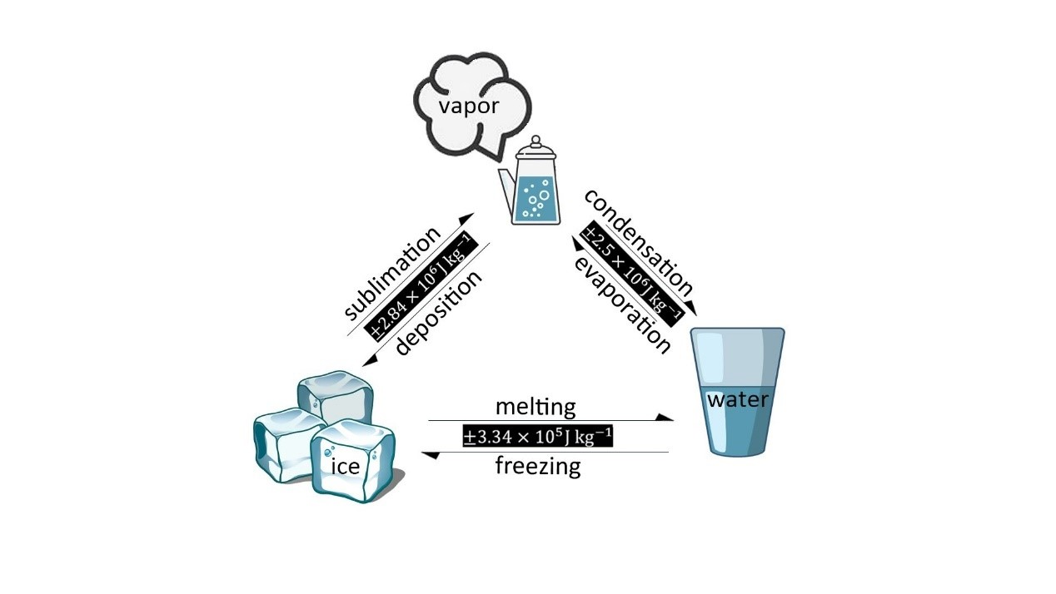

Fig. 1.1 Diagrams of water transitions between solid, liquid, and gaseous phases and accompanied energy absorption or release.

When searching on the Internet, there are quite a lot of well-written materials about this topic for the general readers. Wikipedia for water cycle is a typical example. It elaborates the key processes in the water cycle and gives the clear definition. But there exist several aspects for improvement, for example, the lacking of maps for the data visualization, no reference to seasonal and temporal changes as well as some widely-used academic concepts (more details in Section 2). Therefore, these wikis can meet the cognitive needs of general readers. But for the audience, who want to know more deeply about this topic, it’s far away from enough. Especially for undergraduates, who are the potential researchers in this field, a more advanced wiki for the water cycle is urgently needed.

To build such a wiki, it’s necessary to get access to global climatological datasets for the data visualization. The modeling results of TraCE-21ka simulation (The transient climate evolution of the last 21,000 years1) are chosen. Then Python programming is applied for the data processing and map plotting. The markdown and web (HTML) language are used for the final website build.

The whole process can be roughly divided into four steps: Literature review and text preparation (Section 2), Python learning and data processing (Section 3), website build (Section 3) and improvement for the final website. The detailed chronological organization and arrangement for the project are described in Section 4 and an introduction for the final product is seen in Section 5. Unless stated otherwise, all data used in the result section are from or calculated from TraCE-21ka Simulation results. Section 6 and 7 contain the summary and self-evolution for this project. More information, like the access to all materials for final product and some figures not included in the website, can be found in appendix part.

1. Results of literature review
   1. Existing wikis

The existing water-cycle wikis by various institutions have been reviewed, including the Wikipedia2, The National Aeronautics and Space Administration (NASA)3, The National Oceanic and Atmospheric Administration (NOAA)4, the United States Geological Survey (USGS)5 and so on. Sharing the similar structure, these wikis start from the water distribution and then describe a variety of components in the water cycle, including the storages and the movements between them (Fig. 2.1). Specifically, evaporation, transpiration, and sublimation, plus volcanic emissions, account for almost all the water vapor in the atmosphere. After the water enters the lower atmosphere, the air currents carry it horizontally or vertically. When the air cools down, water vapor is more likely to condense from a gas to a liquid to form cloud droplets. Cloud droplets can grow and produce precipitation, which is the primary mechanism for return water back to the Earth’s surface. When precipitation falls over the land surface, some of it evaporates, returning to the atmosphere; some seeps into the ground as soil moisture or groundwater; and some runs off into rivers and streams. Almost all of the water eventually flows into the oceans or other bodies of water, where the cycle continues.

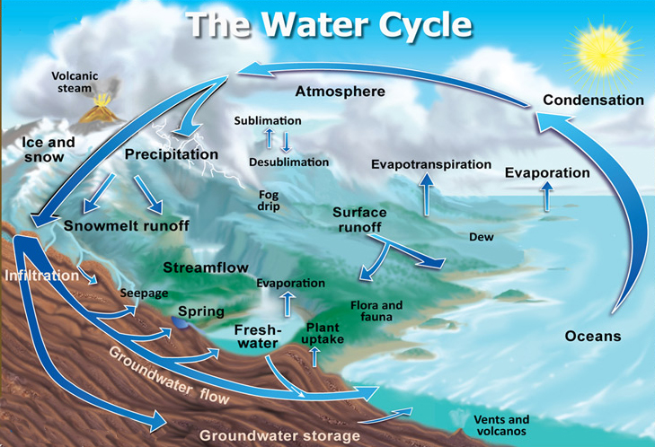

Fig. 2.1 The diagram of the Earth’s “Natural” water cycle, omitting the significant impacts of human influences5. Credit: John Evans and Howard Periman, USGS.

The climatological importance is also mentioned, but only in a few simple sentences. Each wiki covers some special contents. The Wikipedia introduces the concept of the residence time2 and the NASA creates a video to visualize the water cycle and also put some focus on the state-of-art observation methods3. Different language versions are provided in USGS’s wiki5. However, there exists some common missing points for these wikis. A bad visualization is caused due to the lacking of maps are depicting the geographic distribution of key processes, like the evaporation and precipitation. In addition, because these wikis are designed for the general readers, some key concepts widely-used in the academic research are not included.

* 1. Textbooks and scientific literature

As an important topic in the academic research, the water cycle is also elaborated and discussed in some professional textbooks and scientific literature. These materials are similarly organized, from the general picture of the global water cycle to the detailed introduction of key processes. However, the significant features are the inclusion of the quantitative analysis in the mathematical language and more discussion about the physical aspects behind each process.

The essential tool for understanding the water cycle is the law of mass conservation. This tool is explained in detail by Kundzewicz (2008)6 and by Hartmann (2015)7 in his book < Global physical climatology>. In addition, Kundzewicz (2008)6 emphasized the relationship between the acceleration of the water cycle, human impact and the ongoing climate change.

Then let’s take the precipitation to exemplify the difference between general wikis and these professional works. In most existing wikis, the authors only present the definition and the reason why precipitation occurs. Some will also include the climatological meaning (i.e. cooling down the earth’s surface), but in a qualitive not quantitative way. As a comparison, Hartmann (2015)7 and Maidment (1993)8 added the geographic distribution of precipitation and the atmospheric processes responsible for that. For example, the largest precipitation near the equator, where the average water content of the air is high and tropical convective systems are responsible for much of the rainfall.

Maidment (1993)8 dived this topic more deeply, introducing the Clausius Clapeyron Equation, which approximately quantify the amount of vapor that a volume of air can carry, and the instrumental measurement and the advanced modeling method for precipitation. The latter is also reviewed by Chahine (1992)9. Therefore, it requires a certain level of mathematical and physical background to understand these advanced texts.

1. Materials and methods
   1. Data source

The climatological datasets in this project are mainly from the transient climate evolution of the last 21,000 years (TraCE-21ka)1. This simulation is completed using the Community Climate System Model version 3 (CCSM3), centered at the National Center for Atmospheric Research (NCAR). CCSM3 is a global, coupled ocean-atmosphere-sea ice-land surface climate model. The major forcings are orbital forcing, atmospheric greenhouse gases, ice sheets and paleography, as well as the meltwater forcing.

The atmospheric model a three-dimensional model in the horizontal (~3.75° latitude-longitude resolution) and with 26 hybrid coordinate levels in the vertical, while for the ocean model, the longitudinal resolution is 3.6° and the latitudinal resolution is variable, with finer resolution near the equator (~0.9°). More information on the setup of this simulation can be found in the Ph.D dissertation of Dr. Feng He10.

The authors provide the monthly and decadal-mean annual time series of the atmospheric model variables, which are available for download as NetCDF (Network Common Data Form) datasets on the Earth System Grid11. The major variables used in this project are evaporation, precipitation, wind velocity, sea surface temperature and salinity.

* 1. Data processing and plotting

Python is an easy to learn, powerful programming language12. The major advantage is that there are a large number of open-source packages providing powerful capabilities for calculation and plotting, which, together with Python’s elegant syntax its interpreted nature, makes it an ideal language for beginners to make rapid application development. Python is compatible in most platforms and the Anaconda Distribution is used in this project13.

The NetCDF4 Python module14 is used to read data from original NetCDF files. Most data of key variables are three dimensional (time, latitude, longitude). The operation of a N-dimensional array object (like array creation, indexing, slicing and shape manipulation) is realized by the NumPy module15, which is the fundamental package for scientific computing with Python. Let’s take the precipitation data to exemplify the processing steps. At first, it is converted from in unit m/s to cm/year. Then the annual average values for the defined time periods are calculated. At last, it’s integrated by latitudes to calculate the zonal averages.

After data processing, it’s the time to visualize the results. At first, we need to put a base map (the world map) to display these geospatial datasets. Cartopy16, a Python package designed for geospatial data processing, helps achieve this intention. The earth surface is projected to a 2-D plane through PlateCarree, a built-in projection method in Cartopy. Matplotlib17 is a Python plotting library which can produce publication quality figures in a variety of formats. Various types of figures are made by some built-in functions in this package, for example, the contours by the contour and contourf function, a 2D field of vector arrows by the quiverkey function and a live animation by the animation function. It’s the core part in this project to produce animated figures and its method is more difficult compared to the others. The principle behind this function is that, when datasets for every frame are well prepared, the program will plot all the frames one by one and erase the previous frame at the same time.

The cmocean package18 contains colormaps for commonly-used oceanographic variables and appropriate colormaps are chosen for each variable. For example, the diff colormap is diverging, with one side shades of blues and one side shades of browns, and it is employed to represent the difference of the evaporation and precipitation between the past and the modern world. This package helps improve the quality of contour plots and make the spatial features more distinguished.

More information can be seen in the Python scripts with detailed comments, which can be found in the Reference 19.

* 1. Website build

After preparing all the required materials, it's time to build the wiki. The main reason for website as the form to display the results is its ability to contain animated figures. Another advantage for a website is its accessibility at any time and place, by kinds of popular medias (e.g. smartphones, tablet computers and laptops). What’s more, cross-reference can be easily realized in html language so as to make the contents more reader-friendly.

There are several steps to produce the website. Firstly, a repository is created on the GitHub website to store the needed figures19, which will be called and then shown in the new wiki code. Then a Markdown-formatted file is created with the building of the wiki framework and the input of text and picture materials. Markdown is a lightweight markup language with plain text formatting syntax20. During this process, the MathJax Plugin for GitHub21, an open-source JavaScript display engine for LaTeX, MathML, and AsciiMath notation, is utilized for the exhibition of mathematical formulas. After that, he Markdown file is converted to an HTML document through Sublime Text 3 software22. Some adjustments are made to improve the beauty of layout, such as the alignment to the center of formulas, figures and tables, and the arrangement of headings. Finally, anchors points are added to facilitate the jump to other location during the reading. It facilitates the existence of a permanent side navigation bar, where the section titles are linked to corresponding paragraphs. When any figure is mentioned in the major text body, a link is added so that the view can jump to the related figures after clicking. The same method applies to the annotations, which supplement some explanations for the better understanding.

1. Chronological project narrative

The workflow of the project is shown in Fig. 4.1. It takes four months, from 1st August to 30th November.

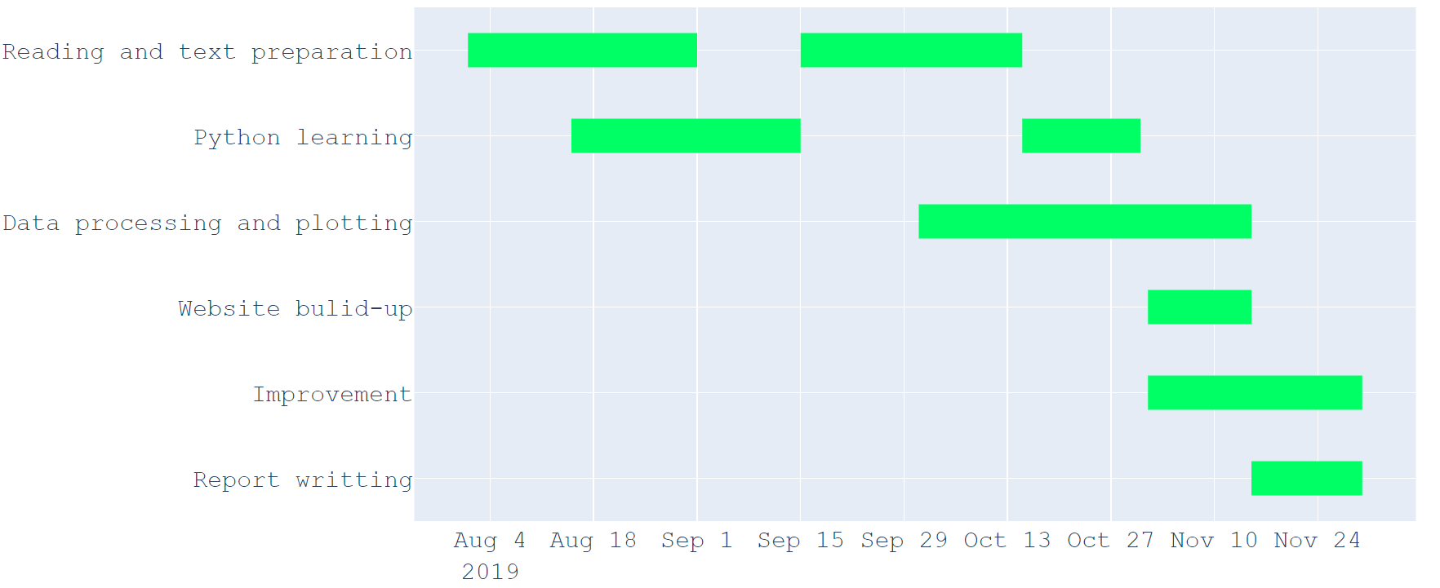

Fig. 4.1 Workflow of the project.

The first step is to read related materials and then decide the logical flow and the needed datasets for the final product. In the first month, I make an overview of the water cycle by browsing and analyzing the existing wikis and reading scientific textbooks. By doing so, I build up the structure for my wiki and decide the processes and elements that will be included. In one month from the middle of September, I fill up detailed texts into the structure and get to know what kind of datasets I would need.

At very beginning, I almost knew nothing about the grammars, rules or functions of Python. It takes me around one and half months to become familiar with this powerful tool. Firstly, I spend one month in learning the basic concepts and features of the Python language and system by reading the official tutorials and watching tutorial videos. I also have access to different open-source packages in this period. Then when I meet some confusing points during the process of analyzing the data and plotting the maps, I learn from the corresponding tutorials and also get help in some professional forums. As a result, I become more and more skilled at Python coding gradually.

The data processing and map plotting is the core step of this project. The datasets are available from the beginning of October. I spend the first week in understanding the structure of the datasets. In the following four weeks, I succeed in plotting the static and animated figures about the geographic distribution of evaporation in each time period. Then the codes for these figures are used as templates and applied for plotting other figures in the first half of November. At the same time, I write detailed comments for each code file to make them more readable for other users.

When finishing the text preparation and maps plotting, all the materials needed for the website build are prepared. In the first week of November, several methods to make a website (e.g. Pelican Static Site Generator, Nikola Static Site Generator) are compared with each other and then Markdown and HTML language are chosen to be used. A draft version of the final website is finished on 15th November.

From the beginning of November, I start to review all the materials and make some improvement for all the materials. In the first week, I try to remove some grammar errors and rephrase some sentences to make them more understood for the readers. The figures description part is also polished to cut out some unnecessary points. Then I spend the second week in adjusting the format for the figures to make sure that the same color pattern, color bar name, text font and size, axis width and so on apply to all the figures used in the website. The remaining time is taken to adjust the layout of the website, including centering the charts and figures, adding anchors from the figures name in the text to the position of figures, designing a permanent side navigation bar and so on.

When these issues are finished, I upload all the materials on the GitHub website and write a ‘readme’ file to describe the product19.

1. Results
   1. Product list

All the materials for the final website are uploaded on the GitHub19 (Fig. 5.1) and it’s accessible and free to use for everyone. The figures folder contains the 20 figures used in the wiki, among which 19 are plotted by myself and the other one has gotten the permission from author. Besides, there are 16 figures for data visualization and 7 figures are animated. The scripts folder contains all the Python codes for data processing and plotting. The html file and markdownToc_files together are the source code for the final website.

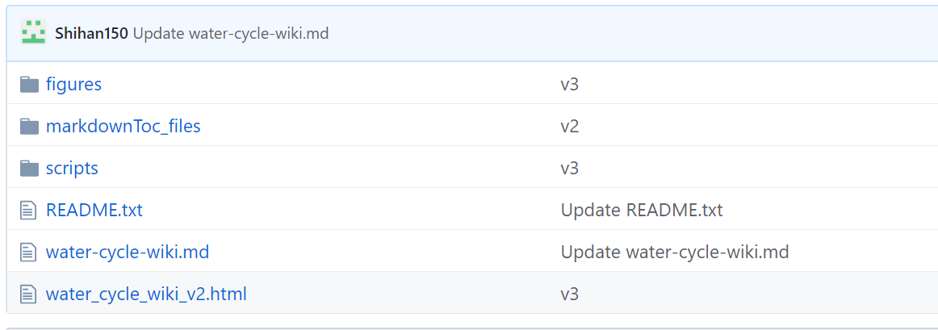

Fig. 5.1 Product list of this project. It’s screenshotted from the GitHub website.

* 1. Logical flow of the wiki

Based on the literature review results (Section 2), wiki is designed with a logical flow shown in Fig. 5.2. It’s divided into two parts: water cycle in the modern world and in the past. Like what other wikis do, I will also start from water distribution. Then I will focus on three processes: evaporation, precipitation and runoff (precipitation minus evaporation). Then the definition and influencing factors for each process are introduced, after which some contour maps are displayed to show the geographic distribution and seasonal changes of each process. The second part covers the temporal evolution, including the past 1000 years and Last Glacial Maximum. Lastly, some more advanced reading materials are recommended.

There are three features that help cover the missing points in existing wikis and thereby make my wiki special. In the beginning, the quantitative analysis tool is introduced so that readers can not only learn some knowledge about this field, but also know how scientists study the water cycle. When describing the major processes in water cycle, some concepts widely-used in academic research are led to readers in a logical and easy-understanding way. including the ITCZ and monsoon, warm pool and the great ocean conveyor. Lastly, for the temporal evolution, I introduce the concept of LGM and some animated figures are used for a better and more intuitive understanding.

There are quite a lot of detailed introduction online about the overlapping points, like the water distribution and definitions for each process in the water cycle. So only the special points will be shown in this report.

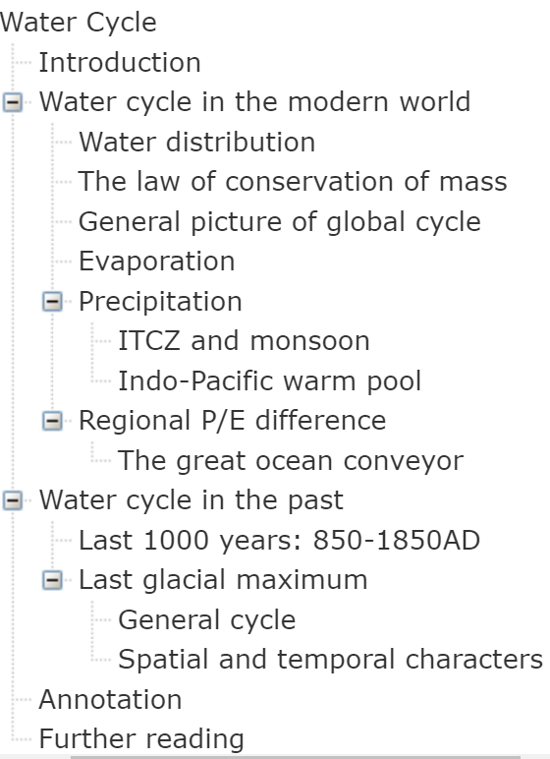

Fig 5.2 The tale of content for the wiki.

* 1. Special features

### 5.3.1 Analysis tool

First let’s imagine a water pool which has an inlet and outlet (Fig. 5.3). After a time interval, the volume change of the pool only depends on the inflow and outflow through the inlet and outlet. In this way, we could deal with the pool as a black box, only focusing on the boundary processes related with input and output while processes inside the pool being neglected. Such a pool is called the reservoir or storage, and the inflow and outflow are called influx.

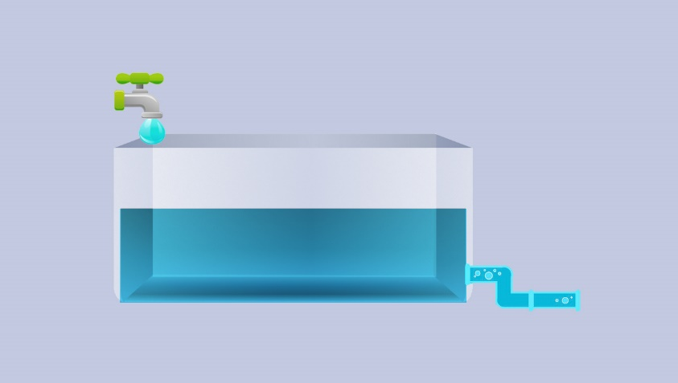

Fig. 5.3 Cartoonish diagrams for the understanding of the rule of balance. The volume change inside the pool only depends on the inflow and outflow through the inlet and outlet.

When studying the water cycle, we apply the similar method. For specific purposes we can define the reservoir of different size and the number of ‘inlets’ and ‘outlets’ will vary correspondingly. Let’s take the ocean for an example. From a global scale, we can mainly focus on the water exchange with atmosphere through evaporation and precipitation, with continents through river runoff and groundwater processes and also with ocean floor. The last one takes place in a much longer timescale, so it will not be discussed here. But from a regional scale, for instance water cycle in a continental sea, besides the aforementioned elements, the exchange with adjunct ocean areas by current must also be taken into account.

This method, which is called the rule of balance or equation of conservation of mass, is the most essential and universal law guiding the study of water cycle. It reads, for any fixed reservoirs (pools):

Inflow−Outflow=Change of storage

In this article, we will primarily include the most essential hydrological processes in earth surface, that is, the total precipitation, evaporation and runoff. Then we can write the surface water balance as:

gw=P−E−Δf

where gw is the change of storage of water at and below the surface, P is the precipitation by rain and snow, E is the evaporation and Δf is the runoff. Terms used here are borrowed from Hartmann’s work7.

Averaged over a long period of time, the storage term is small. Hydrosphere is a closed system and water takes part in recycling rather than loss and replenishment processes. The resulting hydrologic balance for a long-term average is:

Δf=P−E

To illuminate the general picture of global water cycle, we divide the surface areas into two large reservoirs: continent and ocean (Fig. 5.4). As stated above, the major water fluxes are evaporation, precipitation and runoff. Every year, the amount of water lifted by solar energy is around 493,000 km3, which is equivalent to about a 1-m depth of liquid water spread uniformly over the surface of Earth. 83% of evaporation (i.e., 410,000 km3) comes from the oceanic surface and 17% (i.e., 83,000 km3) from land. About 90% of the volume of water evaporating from oceans precipitates back onto oceans, while only 10% is transported to areas over land, where it precipitates. About two-thirds of the latter evaporate again and one-third runs off to the ocean.

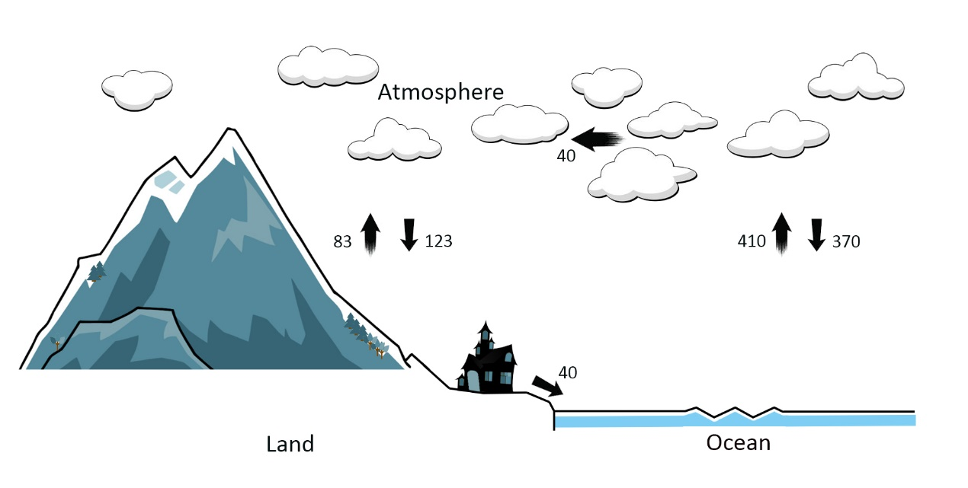

Fig. 5.4 Principle of the water balance between ocean and continent.

Based on these data, we can get the hydrologic balance equations for globe, continent and ocean. From the global scale, the volume of precipitation is equal to that of evaporation. But from continent’s or ocean’s perspective, there is the imbalance between precipitation and evaporation. This kind of difference represents the atmospheric water vapor transport from oceans to land, also being equal to the total runoff of Earth’s rivers and groundwater to the ocean.

### 5.3.2 Academic concepts

#### 5.3.2.1 ITCZ and monsoon

From Fig. A1 (in the Appendix section), we see that rainfall on Earth is most intense near the equator. This narrow belt is called intertropical convergence zone (ITCZ). It is a belt of low pressure where the trade winds of the Northern and Southern Hemispheres come together (Fig. 5.5). As these winds converge, moist air is forced upward, rises and cools, causing water vapor to be "squeezed" out and resulting heavy precipitation.

Fig. A1 also shows that, as the ITCZ migrates seasonally, some tropical zones will experience seasonal precipitation change. On the other hand, since the heat capacity of the continent is small compared with that of the upper ocean, the amplitude of the annual cycle in land surface temperatures is far greater than that occurring in tropical sea surface temperature. Therefore, these zones can also experience seasonal reverse of dominant wind direction. Such seasonal changes in atmospheric circulation and precipitation are called monsoon.

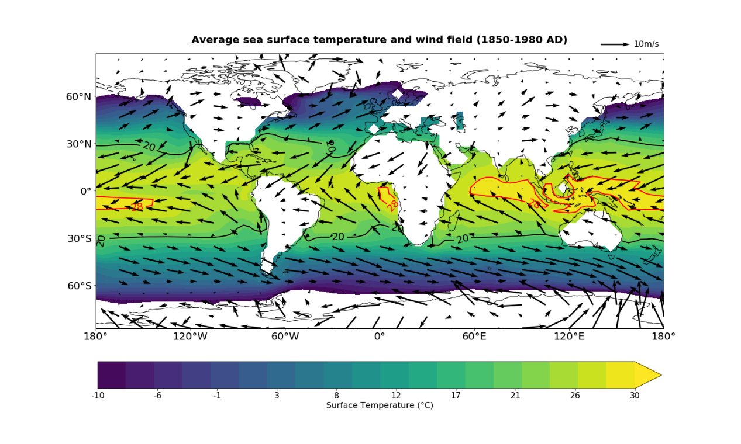

Fig. 5.5 Mean sea surface temperature distribution map with wind velocity vector superposed. The direction and length of arrows demonstrate the wind direction and velocity.

During the winter phase of the monsoon, there is a low-level flow of dry, cool air from the cold continent to warmer ocean, and precipitation over the land is light. During summer, there is a flow of atmospheric moisture from the tropical ocean to the warmer land, where the upward motion of the heated air produces the heavy rains of the monsoon season. The Asian-Australian monsoon system is the most dominant monsoon circulation of the earth, where the summer-winter precipitation difference can reach more than 300 cm/year and monsoon areas extend furthest northward in east Asia (to around 30°N) . Such monsoon-type circulations also occur over west Africa and portions of Mexico and Central America. It’s also interesting to note that similar but less pronounced precipitation oscillation can also be observed in tropical ocean areas, which are far from the continents.

#### 5.3.2.2 Indo-Pacific warm pool

Another noteworthy area is the western tropical pacific, where the annual mean sea surface temperature in highest (>28°C, Fig. 5.5). This area is called Indo-Pacific warm pool. Intensive precipitation and evaporation also take place here. Since these hydrologic processes are accompanied with large amount of energy transfer, the warm pool zone is an important source to drive the atmospheric circulation and thereby the water cycle as well.

#### 5.3.2.3 The great ocean conveyor

Almost all the continental areas are with a positive P/E balance (Fig. 5.6). In the meridional direction, evaporation exceeds precipitation in the belt from 15 to 40 degrees of latitude, and these regions export water vapor to be condensed in the latitudes where the precipitation maxima occur. This P/E difference distribution implies the net transport of water vapor in the atmosphere from the subtropics to the equatorial and high latitude zones. A return flow in the oceans or rivers carries water back toward the subtropics.

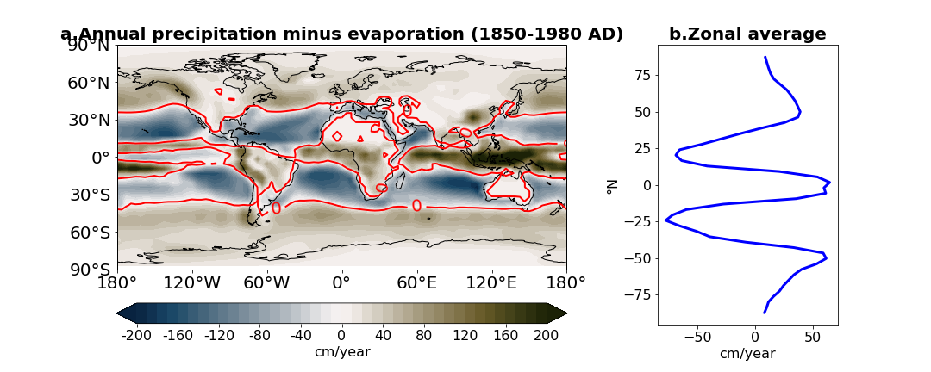

Fig. 5.6 Global and zonal distribution of annual P/E difference in modern world.

In the zonal direction, the dominant trend in the Atlantic Ocean is the net water loss, resulting in the enrichment of salt in Atlantic Ocean. Fig. 5.7 shows that, at the same latitudes, Atlantic is saltier than Pacific. Had the salt buildup not been compensated, the Atlantic's salinity would have increased gradually. Obviously, this cannot have been the case. Therefore, there must be some pathway to compensate the freshwater loss and the salt buildup taking place in Atlantic.

Scientists do find such a pathway. The streamfunction map can tell us the net water flux and direction between any two points in the map. The water flux equates the difference between two streamline values and the direction is the right angle from the larger value to the smaller one. Fig. 5.8 shows that, surface Atlantic water (fresher) flows northward and deep part (saltier) southward, and it’s exactly the opposite for the Pacific.

The water movement in the Atlantic and Pacific is the component of a global-scale circulation, which is called the great ocean conveyor (Fig. 5.9). The conveyor belt transfers warm water from the Pacific Ocean to the Atlantic as a shallow current and returns cold water from the Atlantic to the Pacific as a deep current. Beginning in the central Pacific, it travels past the north coast of Australia and around the southern tip of Africa before moving up into the Atlantic. By the time it arrives the northern Atlantic and passes Europe, the surface water evaporates and the ocean water cools, releasing heat to the atmosphere. As the water becomes colder, it becomes dense enough to sink into depth. The deep water slowly travels south through the oceanic abyss, eventually mixing upward to the surface in different parts of the world. The whole process takes 1-2 thousand years.

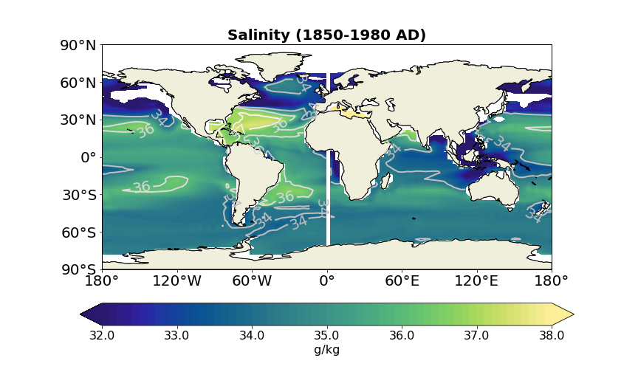

Fig. 5.7 Global sea surface salinity map.

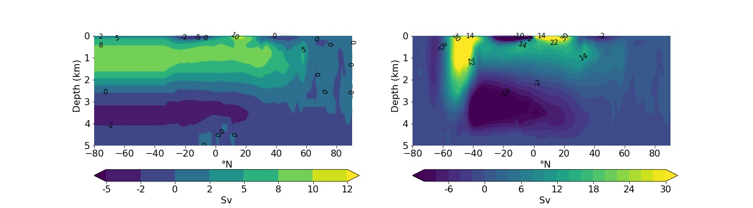

Fig. 5.8 Annual-mean streamfunction (Sv, 1 Sv =106m3/s) in Atlantic (left) and Pacific (right) ocean averaged over 1850 to 1980 AD.

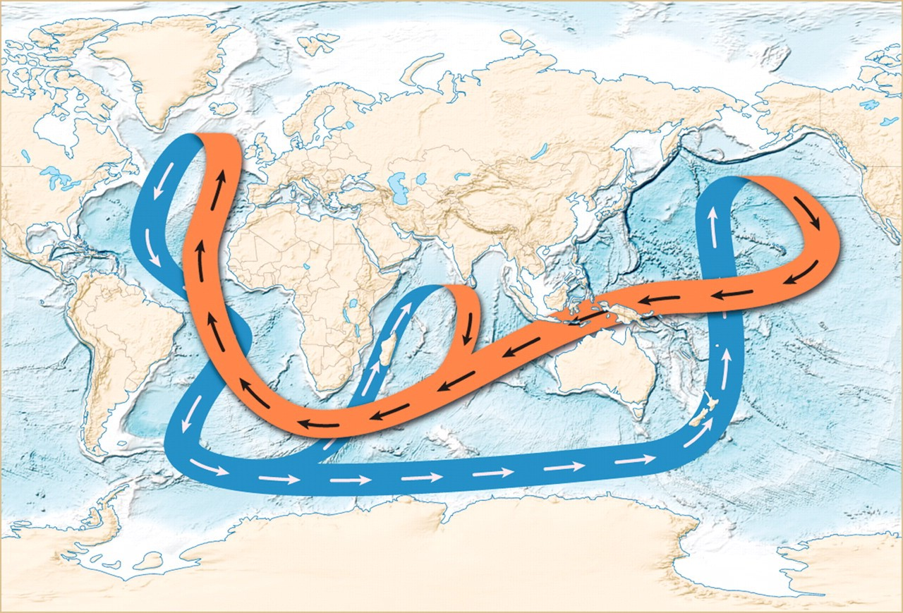

Fig. 5.9 The cartoon diagram for depicting great ocean conveyor. The orange line marks the surface current while the blue marks the deep circulation. Credit: Joe LeMonnier.

### 5.3.3 Temporal evolution

#### 5.3.3.1 Last 1000 years: 850-1850AD

Some regional drought or flood events can be identified during 850-1850 AD from Fig. A2&A3, however, from a larger scale, the hydrologic cycle is almost same as that in modern world. For evaporation, the northern Atlantic undergoes the oscillation regularly, ranging from <-40 to >20 cm/year. The precipitation varied much more frequently and the changes mainly concentrate on the tropical zones.

#### 5.3.3.2 Last Glacial Maximum

When 21 ka BP (ka BP, thousand years before 1950), Earth’s surface was totally different from its current appearance. The mean global surface temperature was around 3-4°C lower23. More water was stored in ice sheets, which covered Canada, the northern United States, northern Europe, and parts of Eurasia. As a consequence, global sea level was about 125 m lower, joining modern islands between Asia and Australia and connecting Britain to mainland Europe. In this world, water cycle also showed different features.

Fig. A4 and A5 shows that during LGM, the geographic distribution of evaporation and precipitation shares similar zonal patterns as that in modern world. Generally, for evaporation, the reduction can be seen in every latitude, with maximum in the tropical and subpolar zones and minimum in the subtropical and polar areas. The evaporation increase can be observed in ocean western boundary in subtropical areas and northern subpolar Pacific and Atlantic. In northern Atlantic and Pacific, extreme decrease occurs between two zones with evaporation increase: subtropical ocean western boundary and subpolar zones.

For precipitation major decrease takes place in the low (10ºN-10ºS) and then high latitudes (>40°), while in the other zones, the value almost keeps same as that in modern world. The largest decrease occurs in the Indo-Pacific warm pool and the northwestern Indian Ocean (by more than 80 cm/year). A small increase even can be seen in the southern subtropical areas. The most distinguished precipitation change takes place in the tropical Pacific Ocean, where western and middle part experience the largest decrease and the eastern part the largest increase (>80 cm/year).

* 1. New scientific insights

When reviewing the contents of the water cycle and analyzing the data, I filled up some blinding points in my knowledge system and got some scientific insights. Followed are two examples.

* + 1. Winter intensification of evaporation

Seasonally, it is evident that oceanic evaporation in each hemisphere is intensified considerably during the wintertime (Fig. 5.10). Such winter intensification is most pronounced over the regions of the Gulf Stream, the northern Indian ocean and Kuroshio, where the value of evaporation exceeds 300 cm/year in winter but is less than 135 cm/year in summer. The main reason is that the surface air in winter for these regions mainly come from the continent, which is very cold and dry, so the surface evaporation is reinforced. This pattern can help explain why the convection takes place in the winter and will be identified more clearly from the monthly average precipitation change (Fig. A6).

* + 1. The global water balance since LGM

From the evolution of precipitation and evaporation over the land and the ocean (Fig. 5.11). For the continent, the volume of evaporation and precipitation sees a moderate increase during 15 ka BP and 6 ka BP, but only show a slight variation between the modern world and LGM, while the water cycle in the oceanic areas accelerated gradually, except some short-period fluctuation.

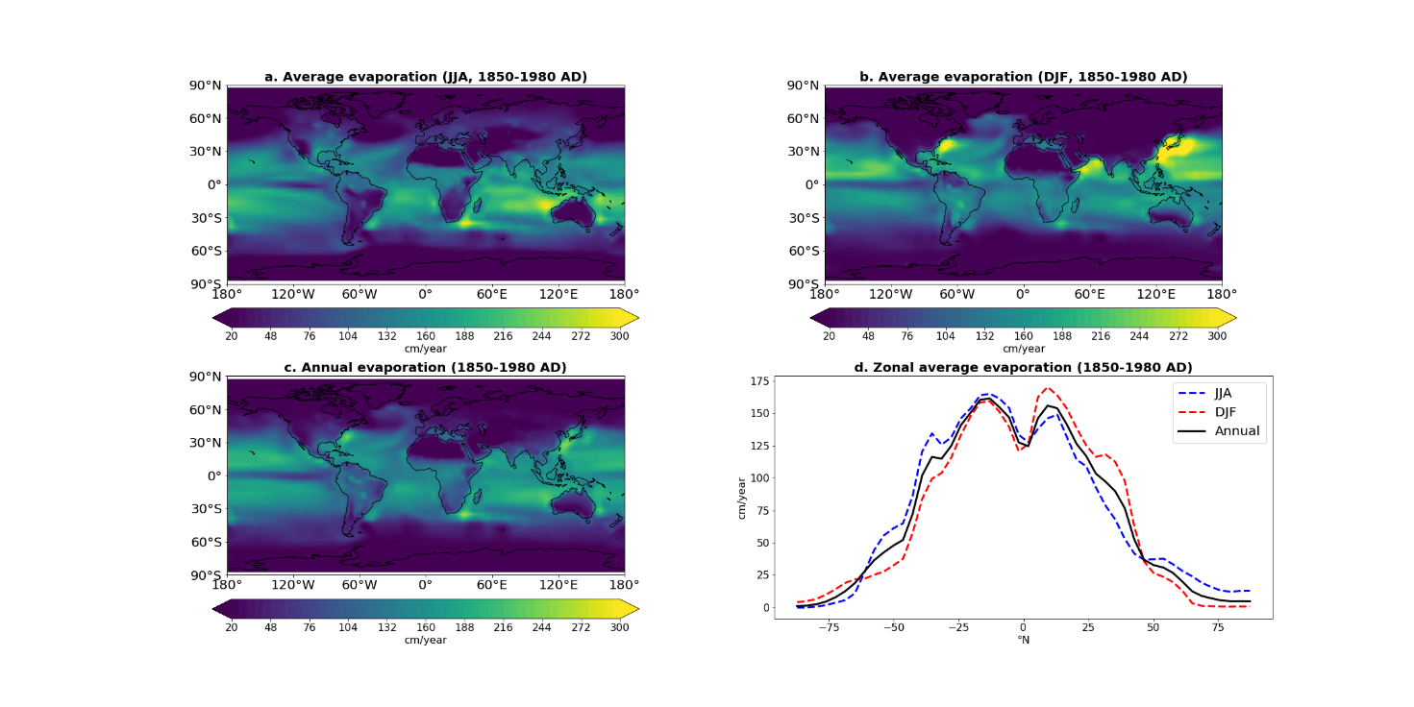

Fig. 5.10 a,b,c Geographic evaporation distribution for the boreal summer (JJA) (a), winter (DJF) (b) and the whole year(c). Zonal average distribution is shown in d. JJA and DJF stands for June, July, August and December, January, February respectively.

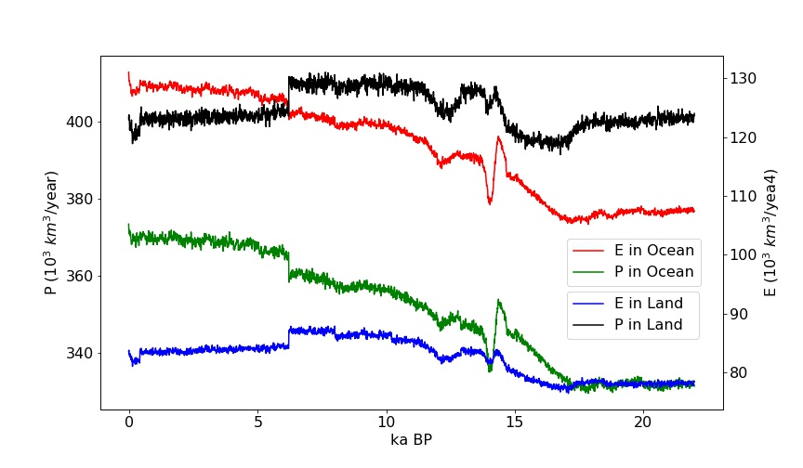

Fig. 5.11 The precipitation and evaporation over the continent and ocean from the LGM to the present.

1. Summary, self-evolution and outlook

Chart 6.1 shows the summary and self-evolution about this project. The initial aim is to build up a more-advanced water cycle wiki for the public readers, especially for the fresh students in the college, and I achieve it in this project. Like what has been shown in the Result part, some missing points in existing wikis are added and it will help the readers get a deeper understanding of water cycle. At the same time, the contents are sieved carefully so as to be prevented from too complicated. Some animated figures are included, by doing so I want to imply the audience that science research could be a cool thing so as to stimulate their interested in relative scientific research. For me, I master the skills of Python programming and website build-up from the zero-based level, which is invaluable for both my academic career and popular science work in the future. What’s more I obtain something unexpected from this project. By making a general review of this topic, I filled up some blinding points in my knowledge system and got some scientific insights when processing and describing the data (details seen in section 5.4).

For the future, my advisor and I considering to upload the wiki on the server of Geosystem Modeling Group and put a link on the website of Geoscience Faculty in the University of Bremen. Apart from that, we plan to translate this wiki into German and Chinese version to make it readable for more students.

Chart 7.1 Self-evaluation table

|  |  |  |
| --- | --- | --- |
| Initial aims | | Self-evaluation |
| For readers | An animated wiki | √ |
| Better understanding | √ |
| Interest stimulation | √ |
| For me | Python programing skills | √ |
| Website build-up skills | √ |
| Unexpected gain | Better review of this topic | |
| Obtain some scientific insights | |

1. Reference
2. TraCE. Available online at http://www.cgd.ucar.edu/ccr/TraCE/, checked on 12/11/2019.
3. Wikipedia (Ed.) (2019): Water cycle - Wikipedia. Available online at https://en.wikipedia.org/w/index.php?oldid=917662161, updated on 12/11/2019, checked on 12/11/2019.
4. NASA Earth Observatory (2010): The Water Cycle. Available online at https://earthobservatory.nasa.gov/features/Water, updated on 10/1/2010, checked on 12/11/2019.
5. NOAA Science. Service. Stewardship.: Water cycle | National Oceanic and Atmospheric Administration. Available online at https://www.noaa.gov/education/resource-collections/freshwater-education-resources/water-cycle, checked on 12/11/2019.
6. USGS: The Water Cycle. Available online at https://www.usgs.gov/special-topic/water-science-school/science/water-cycle?qt-science_center_objects=0#qt-science_center_objects, checked on 12/11/2019.
7. Kundzewicz, Z.W., 2008. Climate change impacts on the hydrological cycle. Ecohydrology & Hydrobiology, 8(2-4), pp.195-203.
8. Hartmann, D.L., 2015. The hydrological Cycle. In Global physical climatology (Vol. 103, pp. 115-135). Newnes.
9. Maidment, D.R., 1993. Handbook of hydrology (Vol. 9780070, p. 397323). New York: McGraw-Hill.
10. Chahine, Moustafa T. (1992): The hydrological cycle and its influence on climate. In *Nature* 359 (6394), p. 373.
11. He, Feng (2011): Simulating transient climate evolution of the last deglaciation with CCSM 3 (72).
12. TraCE. Available online at https://www.earthsystemgrid.org/project/trace.html, checked on 12/11/2019.
13. The Python Tutorial — Python 3.8.0 documentation (2019). Available online at https://docs.python.org/3/tutorial/, updated on 12/5/2019, checked on 12/11/2019.
14. Tutorials — Anaconda documentation (2019). Available online at https://docs.anaconda.com/anaconda/navigator/tutorials/, updated on 12/10/2019, checked on 12/11/2019.
15. netCDF4 API documentation (2019). Available online at https://unidata.github.io/netcdf4-python/netCDF4/index.html, updated on 12/4/2019, checked on 12/11/2019.
16. NumPy — NumPy (2019). Available online at https://numpy.org/, updated on 8/27/2019, checked on 12/11/2019.
17. Introduction — cartopy 0.17.0 documentation (2019). Available online at https://scitools.org.uk/cartopy/docs/latest/, updated on 9/12/2019, checked on 12/11/2019.
18. Matplotlib: Python plotting — Matplotlib 3.1.1 documentation (2019). Available online at https://matplotlib.org/, updated on 11/21/2019, checked on 12/11/2019.
19. Beautiful colormaps for oceanography: cmocean — cmocean 0.02 documentation (2019). Available online at https://matplotlib.org/cmocean/, updated on 11/21/2019, checked on 12/11/2019.
20. Shihan.github.io. Available online at https://github.com/Shihan150/shihan.github.io, checked on 12/11/2019.
21. Markdown Tutorial (2019). Available online at https://www.markdowntutorial.com/, updated on 10/18/2019, checked on 12/11/2019.
22. Consortium, MathJax (2019): MathJax. Available online at https://www.mathjax.org/, updated on 10/16/2019, checked on 12/11/2019.
23. Sublime Text Tutorial - Tutorialspoint (2019). Available online at https://www.tutorialspoint.com/sublime_text/index.htm, updated on 12/11/2019, checked on 12/11/2019.
24. Shakun, J.D., Clark, P.U., He, F., Marcott, S.A., Mix, A.C., Liu, Z., Otto-Bliesner, B., Schmittner, A. and Bard, E., 2012. Global warming preceded by increasing carbon dioxide concentrations during the last deglaciation. Nature, 484(7392), p.49.
25. Appendix

Due to the limitation that animated figures can’t be played in this report, they will be attached together when being submitted. Only the figures’ titles are listed here.

Fig. A1. Geographic and zonal distribution of monthly mean precipitation.

Fig. A2. Global and zonal evaporation difference between last 1000 years and the modern world.

Fig. A3. Global and zonal prectipitation difference between last 1000 years and the modern world.

Fig. A4. Global and zonal evaporation difference between LGM and the modern world.

Fig. A5. Global and zonal precipitation difference between LGM and the modern world.

Fig. A6. Geographic and zonal distribution of monthly mean evaporation.

All the materials have also been uploaded on the seafile website of the University of Bremen (https://seafile.zfn.uni-bremen.de/d/b4cd2acd79d647a3b634/), which is only accessible with a uni-bremen account.

1. Acknowledgement

I would like to express my special thanks of gratitude to my advisor (Dr. André Paul) who gives me the golden opportunity to do this wonderful project on the topic and many invaluable suggestions and instructions.

Secondly, I would also like to thank Dr. Feng He, who operated the TraCE-21ka simulation and made the results freely available. and friends who helped me a lot in finalizing this project within the limited time frame.

Finally, the improvement for the product an 't be completed without the support and help from my friends and colleagues. who help me design some figures and provide me the feedback for the website.